#Jash Mehta

#Homework Info Viz

#Installing package ggplot2

install.packages("ggplot2")

library(ggplot2)

require(ggplot2)

#Loading mtcars data into mtc

mtc <- mtcars

mtc

str(mtc)

#Step 3 A

#Histogram for mpg

a<-ggplot(mtc, aes(x=mpg)) + geom_histogram(binwidth=5,color="black", fill="white")

a

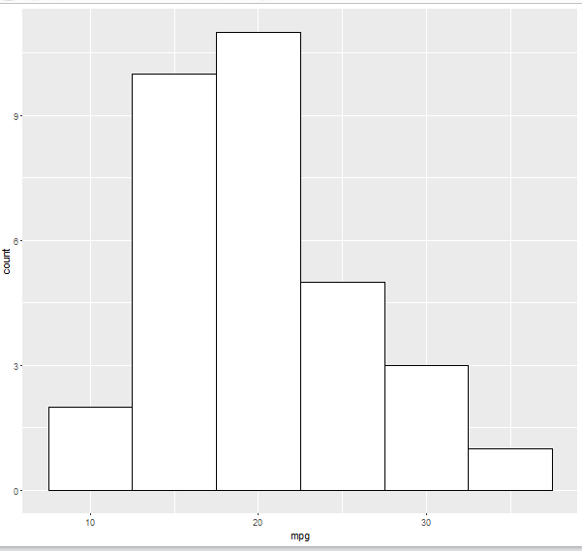

#Boxplot of mpg by cyl

b<-ggplot(mtc,aes(factor(cyl),mpg)) +geom_boxplot()

b

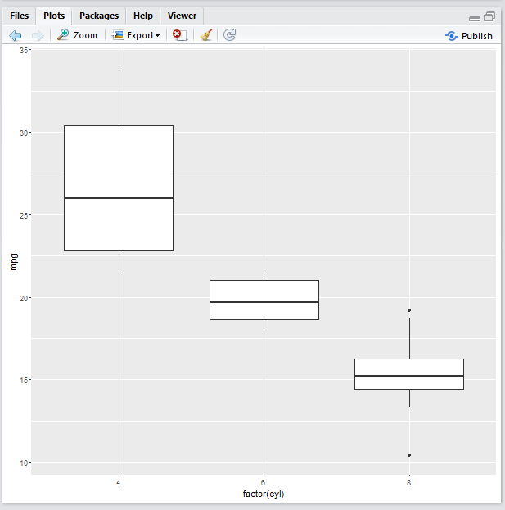

#MultiLine chart

c=ggplot(mtc, aes(x=wt, y=mpg, group=am)) +geom_line (aes(color=am))+geom_point()

c

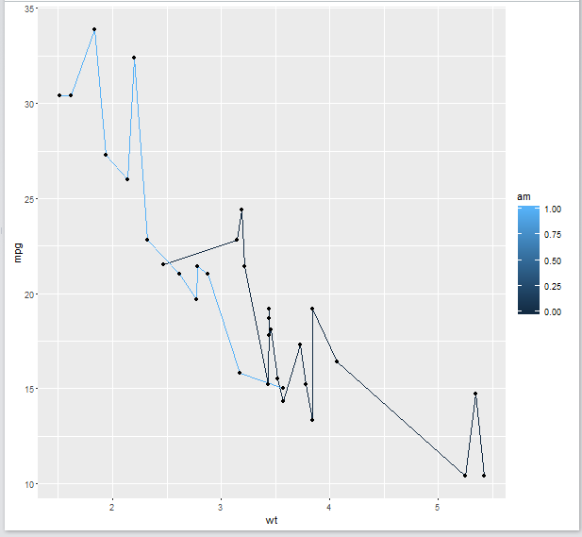

#Bar chart

d<-ggplot(mtc,aes((x=rownames(mtc)), y=wt,group=1))

d<-d+geom_bar(stat="identity")

d<-d+theme(axis.text.x=element_text(angle=90,hjust=1))

d

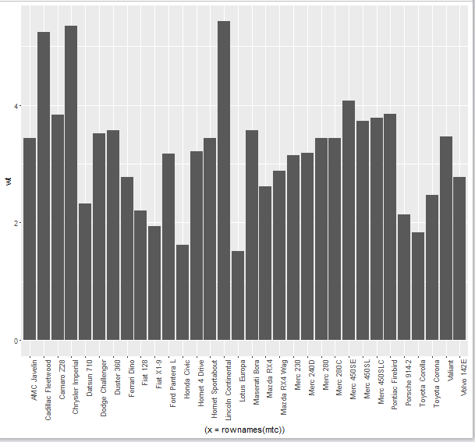

#Scatter plot

e<-ggplot(mtc,aes(x=mpg,y=wt))

e<-e+geom_point(aes(size=qsec,color=qsec))

e

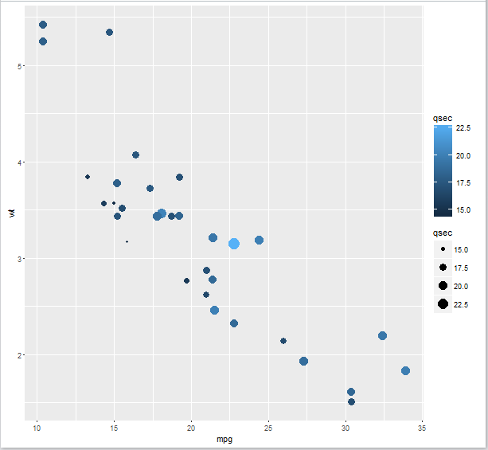

#Creating the heatmap

heat<-ggplot(mtc, aes(y=cyl,x=wt))

heat1<-heat+geom_tile(aes(fill=mpg))+scale_fill_gradient(low="white",high="orange")+xlab("")+ylab("days")

heat1

